2009 National Technical Conference & Exhibition, New Orleans, Louisiana

AADE 2009NTCE-17-05: Drilling Dynamics overview for Deepwater Gulf Of Mexico Salt Drilling.
Author(s) & Affiliations:
Tony Leavitt, Schlumberger Technology Corporation

SPE & AADE Member

Abstract
The probability of drilling into salt in the average Deepwater Gulf of Mexico (GOM) well is extremely high. Some operators have even planned bottomhole assemblies (BHAs)/hole Sections through no less than five salt intervals. Obtaining the well total depth (TD) under authority for expenditure (AFE) requires optimizing drilling of these salt sections by choosing the most economic and reliable bit/BHA/reamer combination to keep rate of penetration (ROP) high while simultaneously mitigating shocks and vibrations in the components of the BHA.
This paper highlights BHA dynamics of multiple BHAs by focusing on overall drilling dynamics and bit/reamer performance of the most popular hole sizes, 18 1/8 in x 21 in and 14 ¾ in x 16 ½ in. These techniques guide informed decisions on bit/reamer selection and drilling parameters that maximize penetration rates without sacrificing BHA longevity. A strong focus on shock mitigation is crucial for any successful salt drilling run. Lessons learned from multiple runs in multiple fields highlight the drilling practices that make a BHA run successful.

Introduction

The ongoing spread-rate today for a Deepwater rig is, for argument’s sake $1 million/day. A “standard” sub-salt Deepwater Gulf of Mexico well is usually planned for 90 to 120 days AFE. Cutting the time off of a Deepwater sub-salt well can increase savings very quickly. However, if a Deepwater project suffers delays as a result of a BHA component failure, a 24-hour. round trip can cost more than the annual gross profits of most small businesses.
The objective for the Deepwater Drilling Engineer is to drill the well in a safe and timely manner. To do this, he must look at all the possible alternatives with regards to BHA design, Casing design, wellbore trajectory, Rig sizing, surface location to avoid shallow gas hazards, Salt Exit location, and Suture/inclusion avoidance, to name a few. Our approach allows us to keep the designed BHA “system” on bottom and drilling efficiently ahead to its planned total depth (TD) without any component failures. The BHA components most susceptible to failure are the measurement-while-drilling/logging-while-drilling (MWD/LWD) tools. Mitigating shocks and vibrations is critical not just in the drilling phase but also in the planning phase of any well.

The Question of Backreaming

In the mid-80’s the invention of the top-drive system (TDS) led to a step-change in the Oil industry. Today, looking for a Kelly-driven system on a Deepwater rig would be an exercise in futility. One of the key advantages of a TDS is the inherent ability for the driller to backream, defined as the practice of pumping and rotating the drillstring while simultaneously pulling out of the hole. This action has gotten drillers out of countless sticky situations.
Salt Drilling applications in the Gulf of Mexico have no inherent need to backream. Wells in these formations are usually vertical and the hole is cleaned very efficiently usually because of the high volume flow rates that bring the cuttings to surface with their high annular velocities and often high-end synthetic-based mud systems. Despite this fact, some drillers are still backreaming on a regular basis, in some cases unnecessarily, merely by force of habit.
When a BHA is off bottom, it looses the point of contact at the bit.. Therefore, the probability for vibrations and associated energy increases. This factor is compounded in the salt when reamers are used as part of the drilling system. In the realm of Deepwater salt drilling, well-designed and centralized salt drilling BHA systems are commonplace. In these systems, the reamer and bit are effectively cutting the homogeneous salt formation equally, sharing the loads of drilling and opening the hole simultaneously. (left side of Fig. 1.) Taking this BHA system off bottom and starting backreaming, will result in a BHA in tension and under tortional stresses. When pulled back into the reamed hole, an uncentralized BHA is susceptible to considerable lateral vibrations. (Fig. 1 right).
Clearly, backreaming is a high-risk activity. Only in very rare cases should it be considered while drilling salt. In the case of sutures and/or inclusions, the same considerations apply; however, in the drilling-on-bottom case the bit and reamer would be cutting formations of different rock strengths, and caution should be the primary focus of the driller. Typically, a lowered weight-on-bit could be used to drill the inclusions, with increased parameters once the inclusion has been drilled by both the bit and the reamer. Because of its very clastic and mobile nature, salt does tend to exhibit somewhat mobile characteristics. Salt creep or closure of the wellbore over time in salt can also result in the need for backreaming. An alternative for this is increased mud weight.
As a result of all these considerations, backreaming in salt formations should be used only after careful consideration by evaluating what the problem exactly, be it sutures, salt creep or rubble zone at the base of the salt. A consolidated plan for backreaming parameters should be specified in case the need arises. Obvious key parameters should be monitored in real-time while backreaming to establish a base-line; these include pump pressure, flowrate, backreaming RPM, real-time torque and drag analysis, and annular pressure values from the MWD.

Size Matters

The question of what reamer size to run with what bit size to successfully run and cement a particular casing string will always be a factor in the overall well design of any Deepwater subsalt well. Table 1 highlights some of the more popular hole/reamer sizes vs. casing sizes run in salt. The decision to run a reamer in the BHA system is, for reasons mentioned above (especially salt creep), a necessity.

Table 1; Casing size vs. Bit & Reamer size.

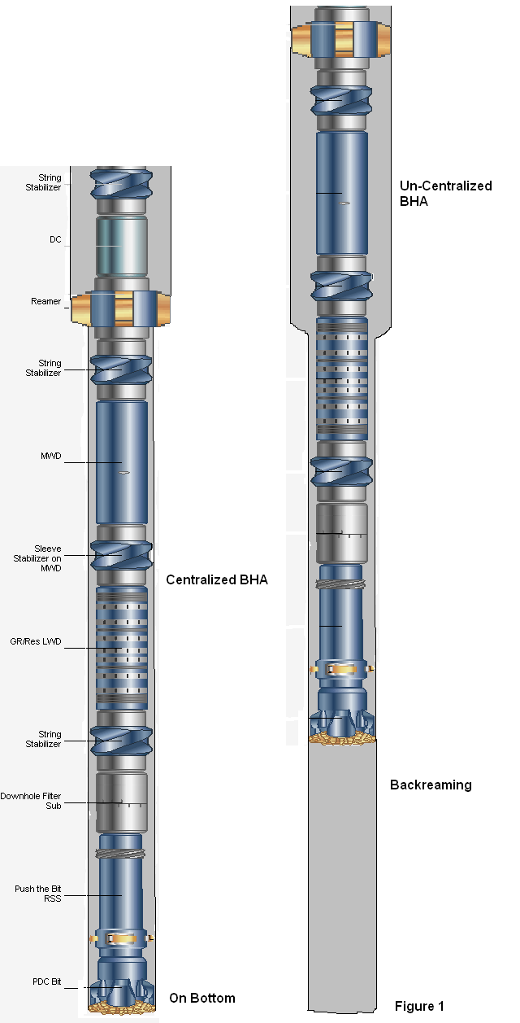

Figure 1; Salt Drilling & reaming BHA on and off bottom
The reamer effectively provides the driller with some assurance with regards to the casing run that occurs after drilling the specified hole section. A larger effective hole diameter will make it easier for the Casing to be run as planned, and will inevitably enhance the cement job by providing a larger annulus, thus reducing the risk of loosing circulation during the cementing process. The question remains, how much assurance is required? In the following example (Fig 2.), a Deepwater GOM operator drilled 5 wells, all through salt and all using a 14 ¾-in. x 16 ½-in. bit/reamer combination, with the exception of Well #4, which utilized a 15 ¾-in. reamer. ROP listed in the chart is on-bottom drilling ROP and does not take into consideration any off-bottom activities such as connections, slow pump rates etc. In all cases the subsequent 13 5/8-in. casing string was run and cemented without incident. As a result of the lower hole size required, an overall increase in ROP can be seen from 135 ft/hr (best case Well 5), to an average ROP of 150 ft/hr for well 4.
In the highlighted wells, we used very similar PDC bit and BHA designs. The other key factors such as Rig capacity (pumps, TDS), crew experience, and environmental conditions such as rig heave and Mud weight have all been “normalized” to make the comparison more focused. The results show that less work is being done to drill and remove formation from the Well 4 example, which could account for the 10% increase in On-bottom drilling ROP.

Fig. .2. ROP comparison based on reamer size.
The Mud Weight Factor
Salt drilling in any environment requires sufficient hydrostatic pressure to minimize the salt creep effect of closing in on the drilled hole. This factor is crucial not only for the casing run, but also to help the drilling process by reducing or sometimes eliminating the high tortional vibrations and stick-slip effects of a hole that is gradually constricting over time. The effective overburden pressure at any depth is usually estimated by the Petrophysicist and can be calculated using seismic and/or resistivity and Sonic Wireline or LWD data. These computations are beyond the scope of this paper however, an example of the negative effects of insufficient hydrostatic pressure (mud weight) can be seen in the following salt drilling example in Fig. 3.
A close-up look at the surface and down-hole drilling parameters of a recently drilled 16 ½-in. x 19-in. salt-interval reveals the advantage of using a higher mud weight to mitigate stick slip and tortional vibrations. In both cases, 13,200 ft.. and at 14,700 ft. MD, the decision was made to increase the Mud Weight as a result of hole problems. The initial reduction in ROP and increase in vibrations is evident; however, these conditions improved with time once the optimal hydrostatic pressure was established. The accepted range for this hydrostatic pressure for this particular operator is between 90 and 95% of the overburden pressure while drilling salt. Not depicted on the depth-based chart is the considerable time spent off-bottom, troubleshooting the situation which included some jarring and the need to pump a 120-bbl fresh-water pill to free the BHA. The nonproductive time (NPT) incurred as a result of the second incident was half a day.
The learnings from this and other previous salt drilling experiences were adopted by the operator, and a mud weight-up schedule was used in a subsequent well. In this 18 ½-in. x 21-in. section, the consistent tortional and Stick-slip vibrations at manageable values, correlate with a solid, consistent ROP performance (Fig. 4). This was a direct result of the drilling Team keeping up with the programmed weight-up schedule to keep the bottomhole hydrostatic pressure in the optimized range between 90 and 95% of the overburden pressure in the salt.
Figure 3; Drilling Parameters vs MW for 16 ½-in. x 19-in. Section
Figure 4; Drilling Parameters vs MW for 18 1/8-in. x 21-in. Section
The Heave Factor
Environmental conditions associated with the seas in the GOM, not only cause weather-related NPT during hurricane season but can also directly interfere with the drilling process. A good heave-compensation system is designed to dampen the effects of ocean waves and hold the drillstring, effectively, in one position; On-bottom with a constant WOB. This is not always the case, even with the most advanced active heave compensation units in operation today; the challenge of drilling in rough-water environments is always a major concern. Actual drilling operations (Bit on bottom), under high rig-heave conditions are suboptimal because they cause fluctuations in the WOB. Not only is the rate of penetration affected, but the overall bit life is also severely compromised. The example (Fig. 5) clearly shows the increased stick-slip vibrations and the WOB fluctuations seen while drilling in a high rig-heave environment. In this 18 1/8-in. hole section, the operator was able to reach TD but not without time spent off bottom and on occasion becoming stuck and having to jar free, thus compromising the overall ROP for the hole section.
Conclusions and Recommendations
Based on these observations and experiences, we conclude the following;
- The optimized mud weight is crucial for the success of any salt run, by keeping the mud weight as high as possible (90 to 95% of overburden pressure), the driller can mitigate the time-driven effects of salt-creep.
- The negative effects of drilling in a high-heave environment can sometimes be negated with a fully functional active heave compensation unit.
We also offer the following recommendations:
- Avoid backreaming wherever possible while drilling salt, especially if a reamer is being used on the BHA.
- Carefully consider reamer size in the decision to run a reamer in a salt drilling BHA, although ROP advantages may be attainable Also, heavily prioritize the obvious risk with regards to the subsiquant casing run.
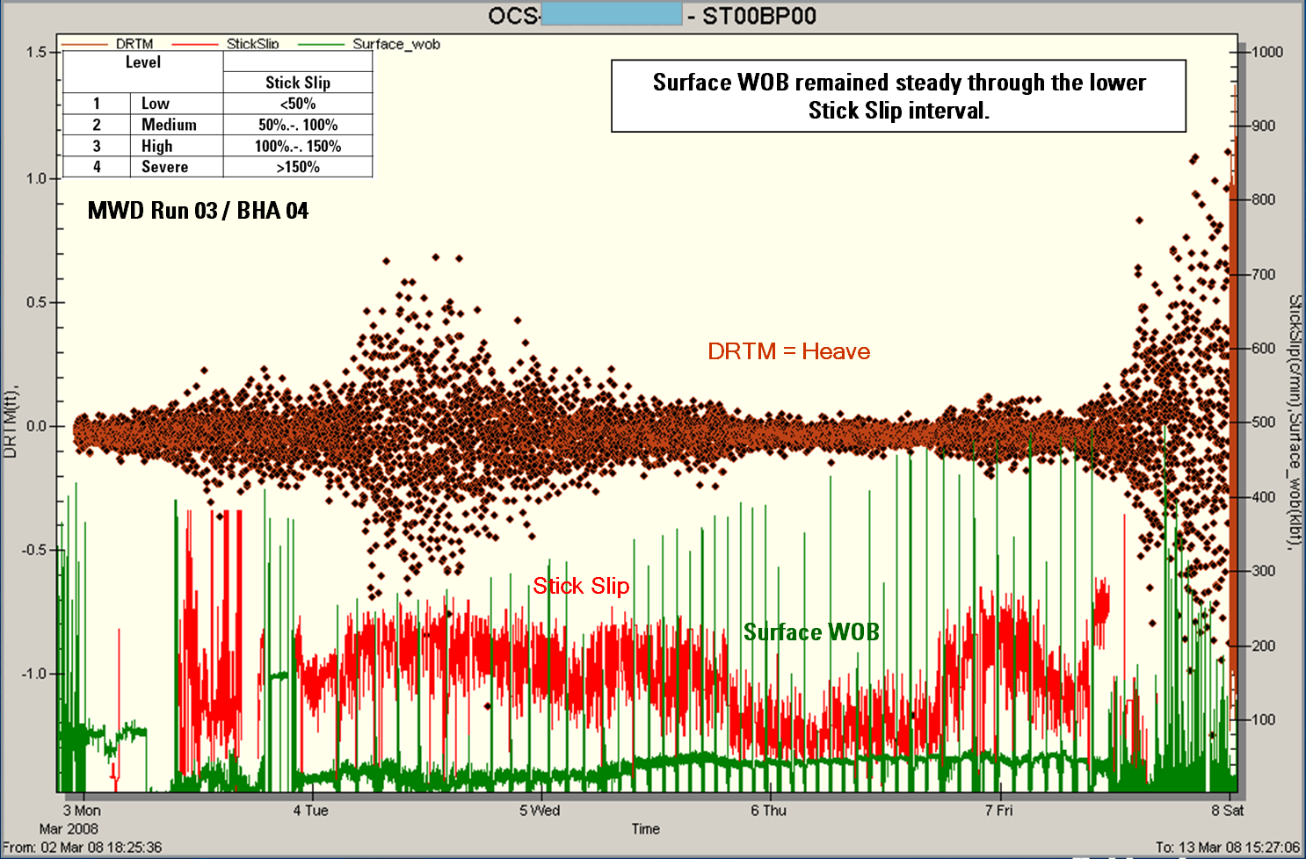
Figure 5; Rig Heave vs. Stick Slip 18 1/8” Salt Section
Acknowledgements
The author would like to Oguz Yalcin and Mike Aubin of Schlumberger D&M for their ongoing engineering support with regards to Deepwater salt drilling experience.
References
1. G. Yarim, GM Ritchie, (SPE), and R.B. May, SPE Schlumberger: “A guide to successful Backreaming; Real-Time case histories” Paper SPE 116555.
2. Chris Lenamond, Agusto Carvalho da Silva: “Fully-Rotating Steerable and Concentric Reamers Technology Combination Eliminate Wellbore Threading in Deepwater.” Paper SPE/IADC 91929.
3. R.R. Israel, P. D'Ambrosio, A.D. Leavitt, Schlumberger, J.M. Shaughnessey, BP America Inc., and J. Sanclemente, Chevron North America E&P Co..: “Challenges in Directional Drilling Through Salt in Deepwater Gulf of Mexico.” Paper SPE/IADC 112669.
4. R.J. Baker, Shell Intl: “Improved Heave Compensation” Paper SPE/IADC 21961.

