2009 National Technical Conference & Exhibition, New Orleans, Louisiana

AADE 2009NTCE-14-02

Applications of Gravity Based Measurement-While-Drilling Real-Time Azimuthal Surveys in Areas of Magnetic Interference
Author(s) & Affiliations:
Euan Forbes, SMITH PathFinder
Allan Rennie, SMITH PathFinder, AADE
Herbert Illfelder, SMITH PathFinder

Abstract
A well path is usually determined from a list of measured depth, inclination, and azimuth values. The standard measurement-while-drilling (MWD) survey system determines azimuth using magnetometers. This downhole survey standard is inadequate for defining the wellbore azimuth in the vicinity of magnetic interference caused, for example, by the close proximity to casing. The standard alternative is to use gyroscopic measurements, either wireline based or as part of an MWD tool. In a previous paper, we introduced an alternate methodology, Gravity MWD®, which uses two separate accelerometer packages in the MWD bottom hole assembly (BHA) to provide an azimuth change between the two accelerometers. These measurements are then accumulated to determine the azimuth of the wellbore at any location.
After a brief introduction to Gravity MWD, this paper focuses on two commercial case studies that demonstrate this technique and reveal cost savings in comparison to other survey methods. The first case study encompasses kicking off from a whipstock in a cased wellbore, dropping angle and turning to intersect a new geological target. The second case study includes drilling a new well from surface, locating and avoiding the old wellbore and continuing to vertically parallel the wellbore to target depth. We will highlight the procedures needed for an accurate real-time determination of the wellbore trajectory and the software that allows for reliable application of Gravity MWD.
Introduction
Traditional wellbore surveys take the form of a list of measurements of the inclination and azimuth (essentially a vector direction or unit-vector) at a discrete number of locations in the wellbore, usually parameterized by the measured depth. These measurements need to be accumulated during drilling to allow the directional driller to correctly control the well path.
The standard source of such measurements during MWD operations is a tool that determines the inclination from a 3-axis accelerometer and the azimuth from a 3-axis magnetometer. This tool has proved both reliable and accurate with mean time between failure (MBTF) greater than 1000 hours usual.
Where magnetic interference makes this impossible, the usual alternative is to use a gyro based MWD tool. This tool is less reliable, requires additional personnel, and is more expensive than the standard MWD. In addition, measurements using gyros take longer and are subject to accuracy issues. However, where real-time surveying results are required, this has proved the usual alternative. Many of these problems are alleviated with a third option, Gravity MWD, which was previously discussed (Illfelder et. al., 2005). This method allows for the determination of inclination and azimuth change – and, as a consequence, azimuth – in areas of magnetic interference. It is based on simultaneous measurement made with 2 sets of rigidly connected, tri-axial accelerometer assemblies. In general, at least one of the tri-axial accelerometer packages is deployed in a standard MWD directional tool allowing the operator to monitor magnetic interference, switch into Gravity MWD mode where required, and then return to standard mode as soon as the interference is cleared.
In two case studies presented in this paper, we demonstrate the application of this product in two separate scenarios. In the first we demonstrate drilling out of casing and switching to standard mode without the need or expense of a trip. In the second example, we show the ability to drill using in standard mode until interference is encountered, switching to the Gravity MWD mode until the interference is cleared, and then returning to standard MWD mode.
RADAR Software Tool for Gravity MWD
In the years since the previous paper, the implementation and presentation of Gravity MWD has been enhanced. The current software evaluation and monitoring tool, RADAR™ (Real-time Analysis for Drilling and Advanced Ranging), is used for a variety of enhanced positioning services including Gravity MWD and well twinning using pre-magnetized casing (Rennie et al, 2008). The user interface presented by the software will vary depending on the application.
Figure 1 shows the display when sidetracking a wellbore using Gravity MWD. This case is discussed as case study 1. The display consists of three plots. Information from the original and side track wellbores is displayed. The x-axis of all three plots is the measured depth of the side track well.
The upper plot shows the inclination. The definitive static surveys from the side track well are represented by the red boxes. In this case, the Z accelerometer was measured while drilling and the interpretation of these data is represented by the blue plusses. The interpolated inclination is shown as the solid green line. Finally, the inclination of the original well is plotted as the solid blue line.
Similar information is displayed for the azimuth data. The red boxes represent the azimuth determined using Gravity MWD. The red line actually consists of overlapping line segments that represent the individual azimuth changes from the individual Gravity MWD measurements. These are spliced together to yield the continuous line with the final interpolated azimuth shown by the solid green line (which is hidden over most of the length). The blue line is the azimuth of the existing wellbore.
Of particular note are the red and blue dots which represent the static magnetic azimuth measured using the 2 triaxial magnetometers. As would be expected, near the original wellbore, the measurements are affected by magnetic interference and are meaningless.
The final plot shows the dogleg severity of the sidetrack. Other displays (not shown) are available to monitor the relative position of the two wells and the output of the dynamic z magnetometer.
Case Study 1 - Baytex Energy Trust
In case 1, we focus on a sidetrack. The plan was to use Gravity MWD until the wellbore exited the zone of magnetic interference, accurately placing this well per the customer’s well plan. The challenges include sidetracking out of the original wellbore at the lowest possible depth, providing real-time azimuthal measurements in areas of magnetic interference, avoiding the original wellbore, and transitioning to standard MWD surveying methods as quickly as possible.
This wellbore is located in the Pembina Field, Alberta, Canada. Tight directional control was required during the sidetrack to minimize the dog leg severity during the kickoff and enable the whipstock to be set at the deepest possible depth. It was drilled using a steerable motor assembly and a dual MWD sensor arrangement (Gravity MWD). The wellbore was planned to drop to vertical as quickly as possible within the dog leg severity limit to a new target.
The MWD BHA (Figure 2) was run in hole to a bit depth just above the casing window at xx23 m (Figure 3) so that the top MWD directional sensor was positioned at a known tie in depth. The reference survey azimuth (a MWD survey from the original wellbore) was utilized to begin Gravity MWD and derive the azimuth at the lower directional sensors position (17 meters behind the bit). The BHA was oriented to 90° right before exiting the window. Gravity MWD surveys were performed in areas of magnetic interference as the BHA exited the window to confirm the accuracy of the tool alignment and quality of the original wellbore surveys (Figure 3). After the initial high dogleg severity experienced from the whip stock, the dogleg severity was kept under 7°/30m during the turn and slight drop of the new wellbore. After the kick off was achieved the BHA was then orientated at 160° right to facilitate the start of the drop. Gravity MWD Surveys were continued to be taken until there was no magnetic interference from the original wellbore. This equated to a radial distance of approximately 12 meters. The lower directional sensor was switched off at this point and conventional MWD surveying procedures were utilized for the remainder of the wellbore.
Case Study 2 - Anderson Energy Ltd.
The objectives of this wellbore were to provide accurate real-time wellbore surveying information while drilling a conventional S shaped well, and to place this wellbore per the well plan. The challenges include locating the original wellbore during the drop section and paralleling the wellbore at a set distance to the bottom target zone. This requirement was due to the narrowness of the channel type bed and was deemed to have the best chance of success of intersecting the target and remaining in the reservoir zone.
The wellbore is located in the Sylvan Lake Area, Alberta, Canada. It was drilled using a steerable motor assembly and a dual MWD sensor arrangement (Gravity MWD) (Figure 4). Note that the directional MWD sensors are at 5.15 m (16.89 ft) from the bit, closer than in case study 1. Experience had shown that a shorter non-magnetic collar below the directional sensor could be used, to bring the directional measurement closer to the bit. (Figure 4). Conventional MWD surveys were used for directional control until the original wellbore was detected. Initial magnetic interference was detected at a measured depth (MD) of 1524 m (4998.72 ft) using the RADAR tool. The original well was located to the NW of its assumed position. A distance of 25.77 m (84.53 ft) to the offset well was measured at 1537 m (5041.36 ft) MD. (Figure 5). At 1683 m (5520.24 ft) MD the minimum separation between the two wells was 10.84 m (35.56 ft). From 1631 m (5349.68 ft) to 1818 m (5963.04 ft) MD the magnetic interference was such that conventional MWD surveys were affected and not accurate. Gravity MWD was then implemented in this area where the proximity of the old wellbore was at its closest. Gravity MWD provided real-time azimuthal measurements until the wellbore was steered clear of the magnetic interference. The wellbore was completed and drilled per the well plan.
Some of the drilling applications for Gravity MWD are outlined in Table 1.
Applications of Gravity MWD
Inside or Near Casing (Magnetic Interference)
Drilling out of casing window
Coming off a whipstock or cement plug
Drilling re-entry work
Casing drilling applications
Drilling past fish
Moving Away from Casing
In any areas of magnetic interference
Table 1 – Drilling applications of Gravity MWD.
Some of the benefits of Gravity MWD versus running a Gyro are outlined in Table 2.
Benefits of Gravity MWD versus Gyro Surveying
No need to rig up and run a wireline Gyro
Risk of stuck pipe during WL operations removed
No additional mud to maintain hole conditions
Man power reductions, increased safety
No need to run a Gyro MWD
No additional surface equipment to rig up
Fast Survey acquisition, on station < 1 minute.
No vendor change at wellsite
Table 2 – Benefits of Gravity MWD versus Gyro Surveying.
Conclusions
Gravity MWD is based on the simultaneous measurement made with two sets of rigidly connected MWD tri-axial accelerometer assemblies. It provides inclination and azimuth in areas of magnetic interference. The RADAR software application processes downhole Gravity MWD survey data and presents these data in graphical form to show the inclination, azimuth and dog leg severity of the wellbore. This allows the operator to visualize the downhole surveys, select the Gravity MWD system when required and provide accurate real-time surveys in areas of magnetic interference while steering the wellbore. Two case studies show the application of Gravity MWD. This solution to the magnetic interference problem obviates the need to run Gyro systems, requires no additional personnel, results in improved safety at the rigsite, and lowers costs by reducing rig time. Gravity MWD applications typically involve drilling out of casing windows from a whipstock or cement plug but can include providing an accurate azimuthal survey in any area of magnetic interference affecting a standard MWD azimuthal survey measurement.
Acknowledgements
We would like to thank Baytex Energy Trust and Anderson Energy Ltd. for allowing us to document the use of Gravity MWD at their wellbores. Heather Heacock at Pathfinder provided graphical support on all the figures.
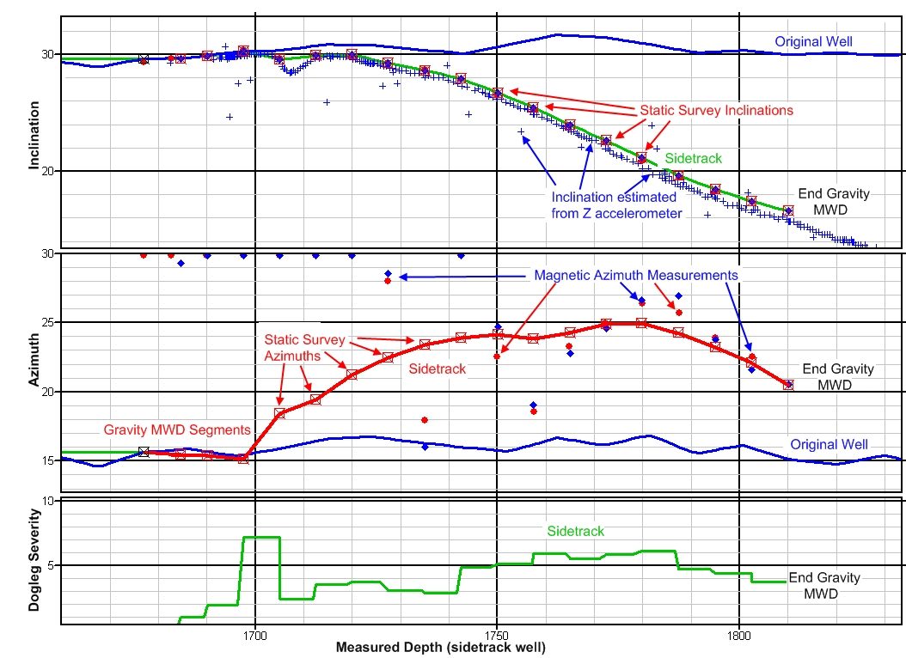
Figure 1- RADAR display of case study 1 wellbore showing Gravity MWD inclination, azimuth and dogleg severity.

References
- Illfelder, H., Hamlin, K., McElhinney, G., “A Gravity-Based Measurement-While-Drilling Technique Determines Borehole Azimuth From Toolface and Inclination Measurement”, paper AADE 05-NTCE-67, presented at the AADE NTCE held in Houston, Texas, April 5-7, 2005.
- Rennie, A., Mcilhinney, G., Illfelder, H., Ceh, L., Schaepsmeyer, H., Krawchuk, A., “A Case Study of a New Technique for Drilling SAGD Twin Wells in Heavy Oil Reservoirs”, paper 2008-395, presented at the WHOC held in Edmonton, Alberta, March 10-12, 2008.

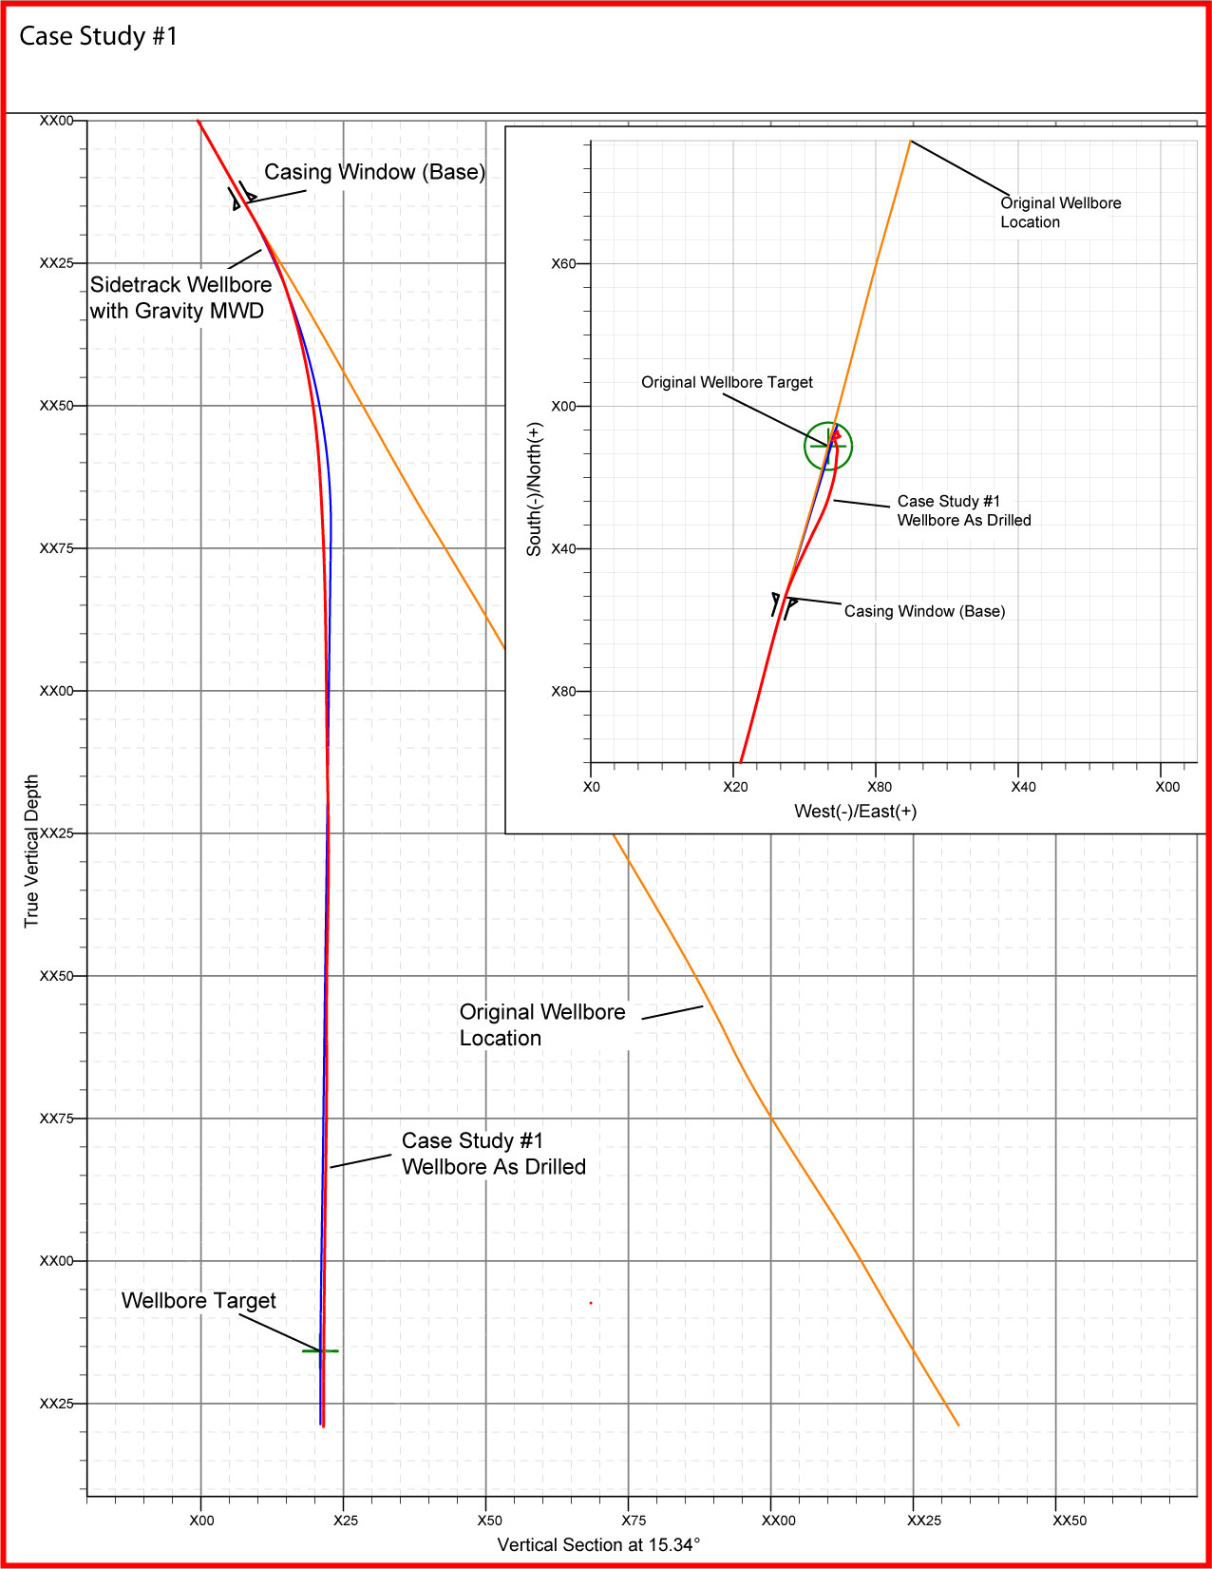
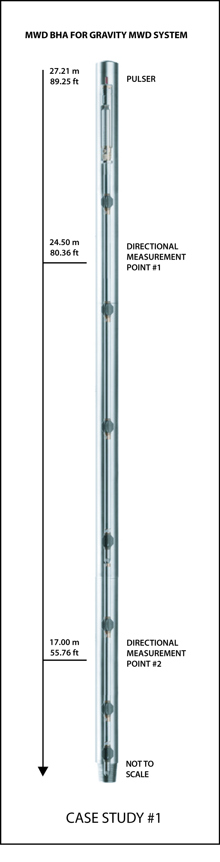
Figure 2 – Gravity MWD BHA. Figure 3 – Well plan of case study 1. Note; Gravity MWD started at the sidetrack at @xx23 m.

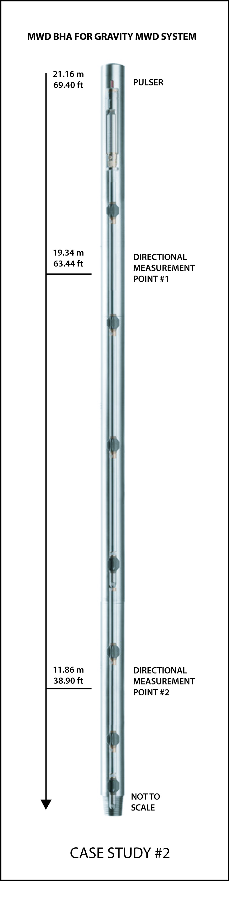
Figure 4 – Gravity MWD BHA Figure 5 – Well plan of case study 2. Note; Gravity MWD is applied from 1631 – 1818 m.

