2009 National Technical Conference & Exhibition, New Orleans, Louisiana
AADE 2009NTCE-13-02: A Case Study of Improved Well Construction Operations Employed By Asia Pacific Operator Where Cutting Edge Technology Resulted in Measurable Cost Savings

Author(s) & Affiliations:
Hank Rogers, Halliburton
Mark Cornwall, Halliburton
Peter Lazaroo, Halliburton
David Edge, Formerly of Halliburton
Abstract
With the ever-increasing demand for oil and gas, operators around the world have increased their drilling budgets in an effort to meet forecasted demand. However, the increased budgets are often eroded or offset by increasing drilling costs. Therefore, operators are continually looking to new technology, processes, or procedures to improve drilling operations and to maximize drilling speed.
One Asia Pacific operator identified a common re-drill operation as a possible area where cost could be easily reduced. Specifically, improvements in procedures and equipment used during shoe-track drilling operations resulted in time savings. This paper documents the successful introduction of wholly-composite subsea-release cementing plugs and their subsequent drillout offshore Western Australia in the Indian Ocean. Historical data is compared to results achieved that validated the anticipated results. The lessons learned and a decision-tree matrix will be presented to enable other operators globally to apply similar cost-saving measures to land, offshore, and deep-water operations.
Introduction
Global drilling operations cover a wide range of environments in search of recoverable reserves that can be produced economically. From shallow drilling operations in the central United States to the jungles of Columbia or drill-ships operating in the open expanse of the largest oceans, our industry continually strives to operate effectively, efficiently, and safely by fine-tuning processes or workflows that are used to implement conventional technology. However, in some cases, operators challenge service companies to provide new technologies that provide more than incremental improvements in effectiveness and efficiencies. Rather, operators demand game-changing technologies to be developed and deployed. Examples of game-changing technologies developed for well-construction operations over the past few decades are rotary steerable systems (RSS), casing while drilling (CWD) and expandable tubulars. Each of these technologies were developed and deployed successfully over the past couple of decades. On a smaller scale, operators continually push service companies to develop new technologies and equipment for primary cementing operations.
In the case of cementing casing equipment and cementing plugs, improved drillability is one area that is constantly challenged because of the high spread costs of today’s drilling platforms. With spread costs for mobile offshore drilling units (MODU) in the range of $400,000 to $1,000,000 USD per day (4.63 to 11.57 USD per second or 278 to 694 USD per minute), the savings gained by the operator for improving shoe track drillout times by 30 minutes or more justifies the cost of new technology. The development of composite resin materials as a replacement of cast-and-wrought aluminum components has enabled equipment suppliers to design, test, and deploy equipment that performs effectively during cementing operations while also allowing [1] shorter drillout times. In some cases, several hours can be saved in the drillout of the shoe track alone. This paper details the development, testing, and deployment of composite subsea release plug assemblies and the value realized by several operators operating off the west coast of Africa and in the Indian Ocean off the western coast of Australia.
Problem-Evaluation Phase
Before a new product can be developed, a details-project-scope must be created that details the deliverables of the project [1]. The deliverables will generally detail performance criteria required by the new equipment, validation testing to be performed with the new product, and clear definitions of how the new product will be deployed. A cross-functional team was created that included designers, drafters, material specialists, and operations engineers. Technical advisers on the team represented the voice of the customer who would ultimately be targeted as users of the new product. Initial product deliverables identified were:
- Improved drillability compared to conventional subsea release-plug assemblies. Target drillout time is 15 to 30 minutes with PDC bits [1].
- Improved wiping and displacement efficiency in the drill pipe and casing.
- Improved versatility of drillpipe darts to cover new drillpipe weights and sizes. One dart for all sizes was proposed.
- Improved job-evaluation capability through improved surface indications of plug launch [1].
- Improved capability to run subsea release plugs in tapered landing strings below a BOP stack on the sea floor.

The cross-functional time created a project charter, the project was funded, and work began [1].
Drillability Problem
Composite resin materials have been available to designers for many years. However, they had not been used in the fabrication of subsea [1] release-plug assembly release-mechanism. A new composite subsea-release-plug system was developed that contained an insignificant percentage of metallic components and composite materials, which have long been considered easily drilled using PDC-type bits. After several design iterations, designs were validated in a laboratory setting for functionality. Once proven to function, drillout testing was performed.
Testing of Composite Plugs
A horizontal drillout test was conducted at a facility in Nisku, Canada on the new composite subsea-release-plug system. A 12 ¼-in. PDC bit with an 8-in. mud motor was used to drill out the composite subsea-release system with a top and bottom plug, as well as special baffle collar and float shoe (Figs. 1-3). The entire target was drilled through in 24:40 min., which is considered a very quick drillout, compared to older subsea-release metallic systems, and falls within the project deliverable of 15 to 30 min. Parameters of the drillout test are detailed in Table 2.
“One-Size-Fits-All” Foam-Releasing Darts
Another problem addressed was the displacement and wiping efficiency of the plug-releasing darts. Conventional drill pipe wiper plugs or darts’ rubber wiping fins are not always suitable for adapting to drillpipe ID restrictions. A material was needed that could better adapt to these geometries. This problem was resolved by replacing the rubber with foam. Foam darts (Fig. 4) were better able to form to the tool joint ID restrictions as they passed through, thus minimizing any kind of flow path and allowing bypassing, thereby reducing cement stringers inside the drill pipe and improving displacement efficiency of the drill pipe wiper plug. The use of foam eliminated the need for numerous wiper configurations that would allow the rubber to conform to the various ID geometries typically found in a drillpipe string. Foam darts led to a sort of “one-size fits-all” releasing dart.
Testing the Foam Darts
One initial concern with foam releasing darts was the foam’s ability to resist collapse when a hydrostatic load is applied. The dart had to be designed such that pressure was allowed to sufficiently migrate throughout the body and thus eliminate a pressure-differential. A test was conducted offshore in the Gulf of Mexico that involved using an ROV to take the foam dart to a water depth of 9,100 ft (2,774 meters). Once the air in the foam was replaced with fluid, the dart was taken down to the total water depth. The camera on the ROV showed that the dart retained its original OD, thus validating its resistance to hydrostatic pressure (Fig. 5).
A second concern was the foam’s resistance to erosion as it passed through the various tool-joint restrictions. A horizontal flow-loop test was conducted at a Louisiana State University facility in Baton Rouge. After being pumped through a total of 19,360 ft (approximately 5901 meters) of 4 ½-in. (114.3 mm) drillpipe, the foam dart did not show sufficient erosion to limit its displacement (Fig. 6). The dart was thus validated for use in subsea-release plug systems that would be pumped at great subsurface depths.
When using foam matrix in the fabrication of the drillpipe wiper darts, a new loading apparatus was required to load the foam dart compared to how conventional wiper darts are installed into top-drive cementing heads. The new loading apparatus was designed for deployment with the foam darts (Fig. 7). The foam dart loading apparatus enables over-sized foam wiper plugs to be installed into restricted-ID top-drive cementing heads safely using a pneumatic air source on the rig. The loading process can be performed on the bank before shipment to the rig, on the deck of the rig, or on the rig floor, though it is preferred not to load on the rig floor because of cost associated with the time required.
Improved Job Evaluation Capability
Conventional subsea-cementing-plug and wiper dart-systems may not provide sufficient tubular wiping or launch indication to evaluate the cementing job as it is performed. Inability to see a surface indication of subsea launching of the cement plugs can result in under displacement of the plugs because of a number of variables. The higher releasing pressures of the new plug system along with great flow area through the plug assembly provide better indications at the surface for evaluating the job.
Two-Piece Cup-Type Isolator Assembly
A study was undertaken to review subsea-release jobs over the past several years to determine exactly how many problem jobs had occurred. One problem that frequently occurred was premature launch of the top subsea-release plug or the inability to land the top subsea-release plug. Post-job investigations into this problem had been inconclusive; however, it was believed that damage to the subsea-release-plug set was caused by excess volume of energized fluid above it that was too great to be equalized through the equalizer valve before damage occurred (Fig. 8). Therefore, additional equalizer valves (Fig. 9) were designed and installed above the swivel equalizer valve already being used. The additional equalizer valves, along with modified procedures that allowed only incremental changes in flow rate, improved the ability to execute cementing operations on wells that used tapered landing strings. Nevertheless, these improvements did not eliminate problems altogether.

Overall, in a high percentage of problem jobs, excess fluid volume above the plug set was identified as the probable cause for an inability to execute cementing operations according to plan. This factor led to the creation of a design project to develop the cup-type isolator assembly. The cup-type isolator assembly (Fig. 10) limits the amount of energized fluid acting above the top cementing plug, thus allowing an equalizer valve to relieve the fluid at a sufficient rate to help prevent a differential pressure across the plug.

Development Project Conclusions

The deliverables of the development project were met with the following items:

- Use of composite materials—A composite subsea-release plug system enables drillability.
- Foam wiper darts—Unreliable displacement efficiency of the drillpipe wiper darts was resolved by replacing their rubber construction with foam. The foam wiper darts provided improved displacement reliability from the drill floor to the seafloor compared to traditional wiper dart performance.
- One-size-fits-all releasing dart—The use of foam eliminated the need for numerous wiper configurations.
- Job evaluation capability—An additional benefit of the new subsea-cementing-plug and dart system is visible surface launch indication of seafloor launches and plug landings on the float collar.
- Packer-cup isolation system—The cup-type isolation system is able to separate a high volume of pressurized fluid from direct application to the cementing plugs. The volume left above the top subsea-release plug was small and consistent and could be relieved at a sufficient rate through an equalizer valve.

Deployment Success Realized
Once laboratory validation testing was complete, the composite subsea-release plug set was deployed offshore West Africa. After several jobs, the composite-plug assemblies began to develop an admirable track record of reliability and dependability. Improvements in drillout times compared to conventional subsea-release-plug sets was a measurable fact (Fig. 11) that was easy to document. As the number of field jobs increased, demand for the composite plug sets continued to grow.
The following details jobs were conducted in offshore West Africa:
- First field trial. Offshore West Africa near Angola, the first 13 ³/₈-in. field trial was performed in 4,500 ft of water. The float shoe was at 6,638 ft. Cementing operations were performed as per procedure. All pressure indications were clearly identifiable on the rig floor and cementing unit (i.e. launch and landing). The casing was tested to 1,500 psi for 5 min. The drillout of the subsea-release plug set and landing collar was performed with a roller cone bit in 17 min. The successful drillout was verified by the customer: “The plugs drilled quickly.”
- Second field trial. Offshore West Africa near Angola, the second 13 ³/₈-in. subsea-release field trial was performed in 1,418 ft of water. The float-shoe was at 4,791 ft. Cementing operations were performed as per procedure. All pressure indications were clearly identifiable on the rig floor and cementing unit (i.e. launch and landing). The drillout of the subsea-release plug set and landing collar was performed with a PDC bit in 15 min. The customer said, “The new style subsea plugs and dart are definitely better plugs than the old style.” The cementer said, “The driller and tool-pusher are still talking about how fast the last set drilled out.”

Indian Ocean Success
During the summer of 2008 and after 100 successful applications of the composite plug set internationally, an Indian Ocean operator chose to use the composite subsea-release-plug assembly for their next well as the first Australian field trial of the new technology. The implementation of the composite subsea-release-plug sets and the subsequent results are documented below. The well parameters for the composite subsea-release-plug set trial vertical-appraisal well were as follows:
Water depth: 677 m
9 ⁵/₈-in. casing shoe depth: 3405 m
SSR-II™ plug landing collar depth: 3379 m
Estimated BHST/BHCT: 100ºC / 77ºC
Well fluid: Seawater
Cement slurry: 15.8 lb/gal Class G
Displacement fluid: Seawater
Connect-Isolator assembly
The cementing team assembled the isolator-assembly pieces and checked that all seals and components were present and greased. The isolator assembly was then bucked up to the wellhead running tool using the bucking machine located on the deck. By doing this offline, significant rig-time savings were made.
Load Plug Sets into Landing Joint
The wellhead running tool was moved with the rig crane over to the subsea-release-plug set. The plug set was lifted and screwed onto the lower connector of the isolator assembly. The fins of the top and bottom plugs were well-greased and the complete wellhead assembly was lifted over to the landing joint, which was sitting in the false rotary located on the deck. The entire wellhead running tool was lowered into the landing joint and attached as per wellhead provider’s procedure (Fig. 12).
The use of the false rotary allowed significant rig-time savings to be made, and allowed the entire process to be performed in a manner that was not rushed; therefore, the job was completed safely. A key lesson that came from this process was that closer attention needs to be paid to the space-out of the running tool and the internal drift of the pipe and crossovers between the plug set and the cement head. This space-out is very important to ensure that the plug set is not sticking out of the end of the landing joint when RIH. For future composite subsea-release-plug jobs, it is recommended that the wellhead running-tool space-out is provided to the wellhead provider so that any space-out issues can be resolved in advance.
All indications show that the cement job resulted in success. The fact that the volume between the bottom plug bypass shear and the top plug landing is the same as what was pumped, demonstrates that fluid did not bypass the plugs and that the entire volume of cement was displaced down the casing. The gradual pressure increase after the bottom plug bypass sheared demonstrates the cement exiting the bottom of the casing and being pushed up the annulus into position (Fig. 13).
When RIH for the shoe-track drillout, the drill-bit tagged cement at 10,990 ft (3350 meters) with 10 klb. The composite subsea-release-plug-set and landing collar was drilled with a high ROP and low WOB until the plug set was observed through a reduction in torque. From the drilling logs (Fig. 14), the drillout of the top of the top and bottom plugs, along with the landing collar, appears to have taken 15-20 min., which was an excellent result compared to what the operator had been experiencing.
The debris returned to surface from the drill out of the plug sets showed that the composite materials (Fig. 15) shredded into small pieces and that the rubber plugs themselves were reduced to a manageable size (Fig. 16).
Conclusion
Laboratory testing and multiple successful field applications using the improved composite subsea-release-plug system indicate that this new technology can positively affect the performance of cementing and drilling operations in deepwater drilling environments worldwide.
The positive results that have come from this field trial have demonstrated the potential cost-saving benefits available through the use of this plug system. On a typical drilling rig spread rate of approximately $1.0 million dollars per day, the two hour savings associated with the composite subsea-release-plug-set translate into a savings of $90,000 per job, based on previous plug-set drill outs taking approximately 2 ½ hours. This rig-time savings offsets the additional cost associated with the composite subsea-release-plugs compared to conventional subsea-release-plugs, therefore making the composite subsea release plug set a feasible improvement for future operations.
Table 1—Drilling Cost
 | Current SSR® Plug System | SSR-II™ Plug System | VALUE
Cost: | ≈$8,000 | ≈$25,000 | -$17,000
Drillout Time | ≈2.5hours | ≈20mins | —
Drillout Cost: | ≈$104,000 | ≈$14,000 | $90,000
Total | — | — | $73,000
Total | — | Value per well (2 strings): | $146,000
Total | — | Value per year per rig (10 wells): | $1.46 mm
Total | — | Total value (4 drilling rigs): | $5.84 mm
Note: Drillout cost is based on a $1MM/day spread rate ($41,667/hr).

Table 2—Periodic Data Obtained During Drillout

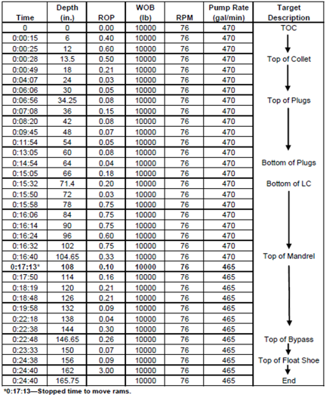

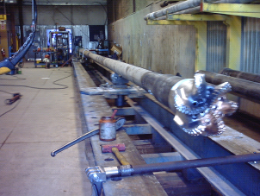
Fig. 1—12 ^{½}-in. (317.5 mm) PDC bit driven by a 8-in. mud motor.

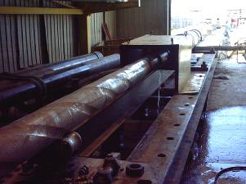
Fig. 2—Drill bit entering the drillout target.

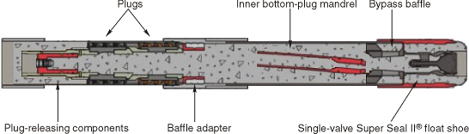
Fig. 3—Composite subsea-release-plug assembly drillout fixture.
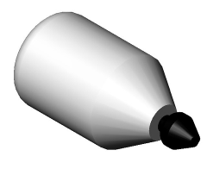
Fig. 4—Foam darts were better able to form to the tool joint ID restrictions.
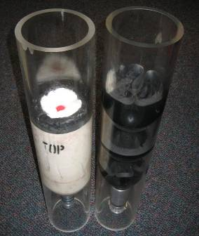
Fig. 5—Two views comparing the new foam dart (left) and a typical elastomeric dart (right).
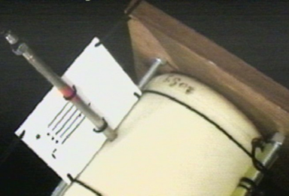
Fig. 6—The camera on the ROV showed that the foam dart retained its original OD, thus validating its resistance to hydrostatic pressure (dart taken to depth of >9,000 ft in the Gulf of Mexico).
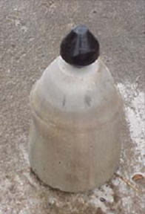
Fig. 7—Foam wiper plug after being pumped over 19,000 ft (5,900 m) through a 4 ½-in. horizontal flow loop.

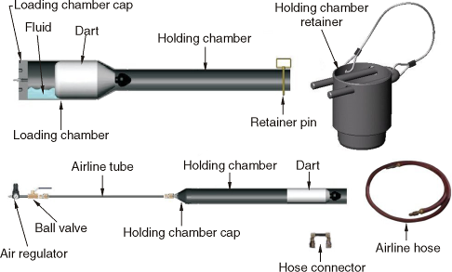
Fig. 8—Foam dart or plug loading apparatus uses pneumatic air pressure to install over-sized foam wiper plugs into restricted-ID top-drive cementing heads.

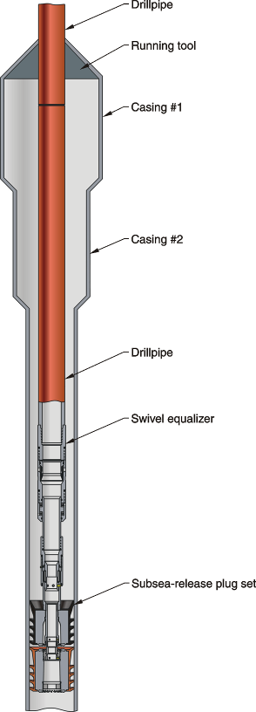
Fig. 9—Tapered landing strings were first used in the late 1990s.

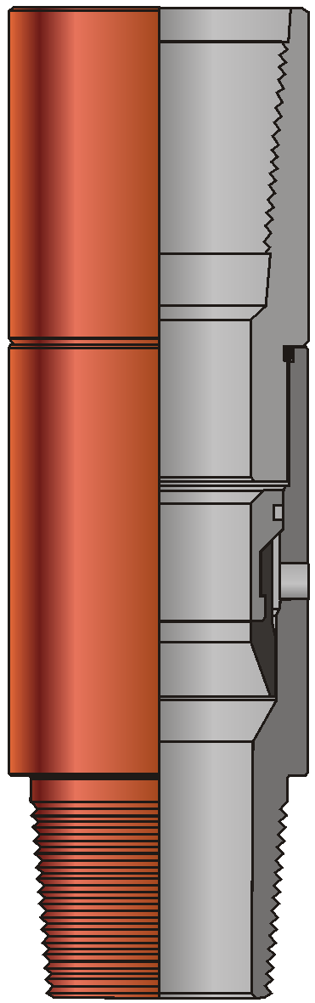
Fig. 10—Stand-alone equalizer to be installed between running tool and plug set. One or more equalizer valves are run in conjunction with swivel equalizers to increase fluid bypass capacity above the subsea-release-plug sets.

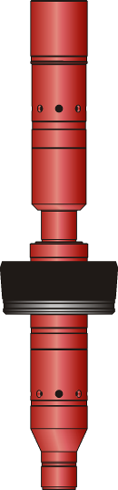
Fig. 11—The cup-type isolator assembly limits the amount of energized fluid acting above the top cementing plug by creating a one-way seal directly above the subsea-release plug.

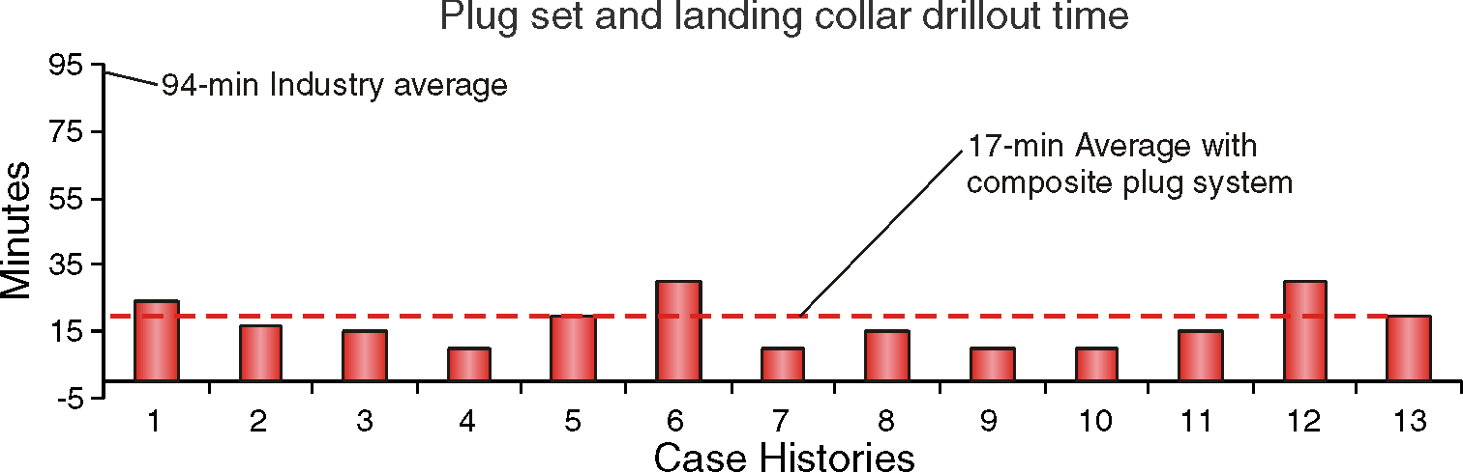
Fig. 12—Drillout summary for the first 13 composite subsea-release-plug assemblies deployed.

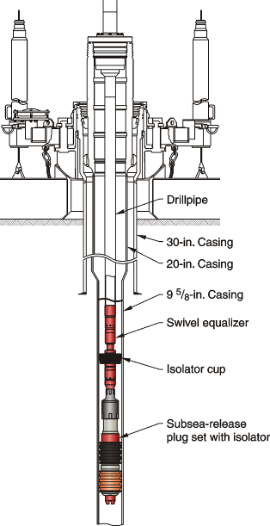
Fig. 13—A general casing configuration deployed offshore Western Australia in the Indian Ocean using the cup-type isolator and a composite subsea release-plug assembly.

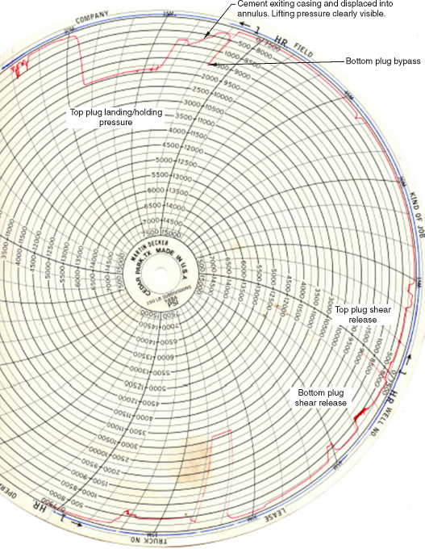

Fig. 14—Martin Decker pressure chart.

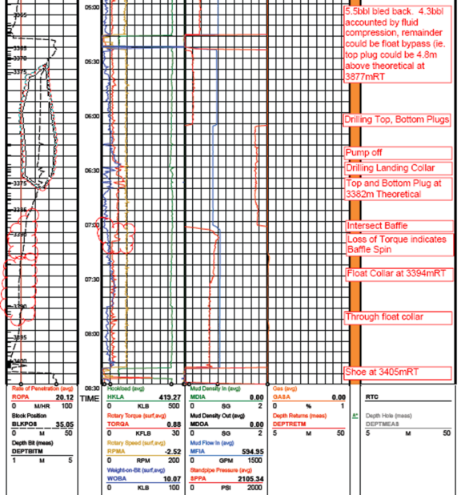
Fig. 15—Mud loggers report for the drillout of the composite subsea release plug assembly and landing collar.

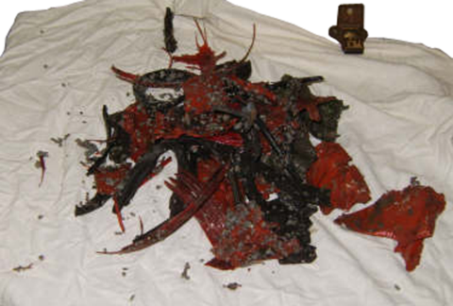
Fig. 16—Debris from rubber plugs.
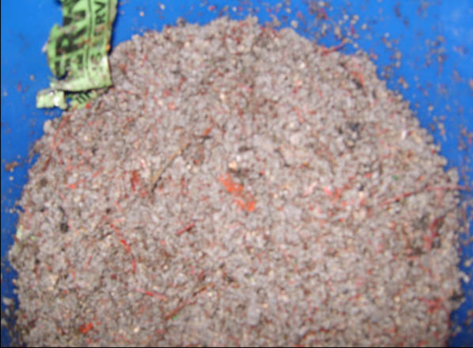
Fig. 17—Debris from composite plug components.

References:
1. Offshore West Africa Cementing with New Subsea-Release Plug System; Hank Rogers, Brett Fears, Frank Acosta, Jason Jeow; Halliburton

