2009 National Technical Conference & Exhibition, New Orleans, Louisiana
AADE 2009NTCE-12-01:
COMBINED EFFECTS OF ECCENTRICITY AND PIPE ROTATION ON DYNAMIC BARITE SAG –ANALYSIS OF DIFFERENT IMPACTS OF PIPE ROTATION IN A FLOW LOOP & ROTATION IN A MODIFIED ROTATIONAL VISCOMETER ON BARITE SAG
Tan Nguyen, SPE, University of Tulsa

Stefan Miska, SPE, University of Tulsa

Mengjiao Yu, SPE, University of Tulsa

Nicholas Takach, SPE, University of Tulsa

Ramadan Ahmed, SPE, University of Oklahoma

Arild Saasen, SPE, University of Stavanger

Tor Henry Omland, SPE, StatoilHydro & University of Stavanger

Jason Maxey, SPE, Halliburton

Abstract
During drilling operations, control of sub surface pressure is of utmost importance. High density minerals such as barite and hematite are used to increase the density of drilling fluids in order to control these pressures. However, contributing factors such as gravitational force will cause the weighting material particles to settle out of the suspension. This is designated as “sag” within the drilling industry and can lead to a variety of major drilling problems including lost circulation, well control difficulties, poor cement jobs and stuck pipe. Study of this phenomenon and how to mitigate its effects has long been of interest.
In this paper several methods for evaluating dynamic barite sag in oil based drilling fluids are examined in a flow loop and using a rotational viscometer modified by addition of a sag shoe (MRV). Tests using the MRV in the range of 0 – 100 RPM were conducted and the effects of rotation speed on sag were correlated with flow loop tests performed by varying the inner pipe rotation speed. The combined effects of eccentricity and pipe rotation on dynamic barite sag in oil based drilling fluids are also described in this paper. Flow loop test results indicate that pipe rotation has a greater impact on reducing sag when the pipe is eccentric rather than concentric. Additionally, results in the MRV indicate a strong correlation between the test RPM and degree of measured sag.
Introduction
Barite sag continues to be a serious problem in many directional wells. The term “barite sag” is used because barite is a traditional weight material used in drilling fluids to increase the density. While there are substitutes such as micromax (manganese tetraoxide), calcium carbonate, and ilmenite (iron titanium oxide), barite is the most widely used weight material because it offers high density with wide availability, favorable economics, and it is environmental friendly.
Most papers^{1, 2, 4, 6, 7, 13} agree that the phenomena of barite sag in inclined tubes are similar to the phenomena discovered by Boycott, who reported in 1920 that blood corpuscles settle faster in inclined test tubes than in vertical ones; that is, particles settle vertically even when the tube is inclined. A thin layer of clarified fluid appears immediately below the upper wall and another clarified region develops at the top of the fluid. Particles settle out of the suspension zone and form a sediment bed. Coincident with a downward slide of the bed, a resulting cross sectional density gradient generates a pressure imbalance. This causes convection currents which drive the lighter fluid up and the bed down, accelerating settling in the suspension zone. The combined downward flow and slide of the bed is called “slumping”.
Saasen et al.², pointed out that sag may occur more rapidly in a fluid that has a fragile gel structure. A fragile gel is one that may exhibit high yield strength but after the initial gel breaks, continues to be easily broken. Therefore, the fluid may have relatively high gel strength and still exhibit severe dynamic sag when exposed to a low shear. They also concluded that static sag can not be predicted from VG-meters; Gel formation is important in avoiding static sag; G’/G’’ can indicate sag potential; Dynamic sag can be large even if static sag is low or absent.
Hemphill et al.^{3, 5, 8} focused on dynamic sag and concluded that: (1) the onset of dynamic barite sag occurs at shear rates less than 4 s⁻¹ in deviated well bores, using invert-emulsion mud. (2) Dynamic barite sag generally increases as hole angle increases from 45 to 60 degrees. (3) Ultra-low shear rate viscosity appears to have a greater influence on dynamic barite sag than mud weight. (4) Dynamic barite sag was generally low at annular velocities above 100 feet/minute. (5) There is no apparent trend between mud weight and levels of dynamic sag. (6) Rheological properties taken from 6-speed viscometers did not correlate with dynamic barite sag potential.
Bern et al.⁶, studied dynamic sag and also gave the operational guidelines to minimize the sag. The authors realized that: (1) Barite sag can be minimized by attention to detail in the areas of well planning, mud properties, and operational practices. (2) Barite sag and hole cleaning are related in principle, but are distinguished by their bed characteristics. (3) Barite beds are more responsive to removal by mud velocity and pipe rotation than most cutting beds. (4) Barite sag can be exacerbated by low annular velocities, eccentric and stationary drill pipe. Also the authors introduced a new model to predict barite sag which was found to be an excellent match for a wide range of data (see Problem Statement).
Zamora et al.¹¹, modified the rotational viscometer by adding a sag shoe into the American Petroleum Institute (API) thermo cup and realized that it could improve the utility of the standard Viscometer Sag Test (VST). By using this modified rotational viscometer, tests at 100 RPM were conducted in 30 minutes. These tests revealed that the results from VST and the results from a flow loop were related.
It is well known that the assumptions for the Herschel-Bulkley model are time-independent, purely viscous, and non-Newtonian fluids. However, Maxey¹² recognized that oil-based drilling fluid is time-dependent and demonstrates viscoelastic behavior. He focused on elastic modulus G’ and viscous modulus G’’ by using Oscillatory Rheometry and found the elastic modulus G’ may increase and decrease with time. This means the yield structure of the fluid may build up and break down over time.
Modified Rotational Viscometer Tests
The purpose of these tests is to study sag tendency of different oil based drilling fluids using a modified rotational viscometer (MRV). The sag shoe provided by M-I Swaco (Figure A1 in the Appendix) is added to an API thermo-cup. The upper surface of the sag shoe is characterized by two sloped, hemispherical sections. The sloped surface helps to accelerate settling and to concentrate the weight material into a single collection well on the sag shoe.
The MRV tests were done using two different oil based drilling fluids provided by Baker Hughes Drilling Fluids. The rheology of these fluids is shown in Table 1.

Table 1: Rheology of oil based drilling fluid # 1 and 2
Oil Based Drilling Fluid 1 (OBDF1) |  | Oil Based Drilling Fluid 2 (OBDF2)
Yield Power Law Fluid |  | Bingham Fluid
n | 0.5 | μ_{p}, cp | 23
K, lbf-s^{n}/100 ft² | 9 | - | -
τ_{y,} lbf/100 ft² | 5.06 | τ_{y,} lbf/100 ft² | 12
Oil water ratio | 80/20 | Oil water ratio | 80/20
ρ, lbm/gal | 13 | ρ, lbm/gal | 12

Presented in Figures 1 and 2 are the density differences between the top (the interface between fluid and air) and the bottom (at the collection well on the sag shoe) as a function of sampling time. When increasing rotation speed from 0 to 100 RPM, the density differences increase in both cases indicating more sag occurs. These results may be expected by most people because increasing the rotation speed of drill pipe is often used to mitigate sag by disturbing the fluid. To explain these results, the relationship between viscosity and shear rate of OBDF2 was studied using a Thermo-Hake RS300, available in Tulsa University Drilling Research Project (TUDRP). The results of this test are displayed in Figure 3: At shear rates less than 5.1 s⁻¹ the viscosity is greater than 400-cP, which is significantly higher than the viscosity (μ < 70-cP) at a shear rate of 102 s⁻¹. Because of this significant decrease of viscosity when increasing the shear rate (shear thinning fluid), settling of the barite particles is much easier. The shear-thinning nature of the mud induces more sag at rotation speeds of 60 and 100 RPM when compared to 0 and 3 RPM. Further impacts on dynamic barite sag by rotation in the MRV will be discussed in detail in the last section.
Dynamic Barite Sag Tests in the Small Scale Flow Loop (SSFL)
Dynamic barite sag experiments were carried out on the Small Scale Flow Loop (SSFL) available in TUDRP (Figures A2 and A3). The flow loop test section is 9 feet long, consisting of a transparent outer casing (2 in. ID) and an inner drill pipe (1 in. OD). The drill pipe can be rotated up to 200 RPM. The eccentricity in this current work will be changed from 0 (concentric case) to 1 (fully eccentric case). The test section can be lifted with an inclination angle ranging from 30 to 90 degrees from vertical.
During circulation, barite particles accumulate in the test section leading to the change of drilling fluid density. This density was monitored by a mass flow meter at the inlet of the test section. Temperature while circulating also was recorded and used to adjust the measured densities to account for the effects of temperatures on density.
Oil based drilling fluid used to conduct tests is defined as “yield power law” fluid with n = 0.687; k = 0.503 lbfxs^{n}/100ft² and τ_{y} = 4.05 lbf/100ft².
Figures 4 and 5 show the combined effects of pipe rotation on dynamic barite sag in the concentric and the eccentric configurations, respectively. The annular velocity and inclination angle are kept constant during the tests with the value of 16 ft/min and 60 degrees from vertical. The results showed that at 0 RPM, sag is more severe in the eccentric case than the concentric case. The change of density in a unit volume of the test section in the eccentric case is 0.815 lbm/gal/ft³ while it is 0.544 lbm/gal/ft³ in the concentric case. It should be noted that the measured density changes are dependant on the volume of fluid using during the tests and the volume of the test section. In this work, the ratio between the volume of annulus and total volume of fluid used to fill up the coil tubing in the mud tank is about 1/20.
Because of such small ratio, the change of density is small. In the field, mud weight variations can be greater than 4 lbm/gal¹ because this ratio is much higher.

Figure 1: Comparison of density change of OBDF1 over time and rotation rates.
Figure 2: Comparison of density change of OBDF2 over time and rotation rates.

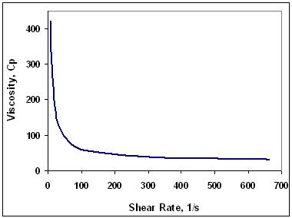
Figure 3: Viscosity vs. shear rate of OBDF2.

When increasing pipe rotation to 20 RPM, the curves in both cases are shifted up, indicating pipe rotation helps to reduce sag. However, the effects of pipe rotation in these two cases are very different: Pipe rotation significantly reduces sag in the eccentric case (Fig. 5) while in the concentric case (Fig. 4) the two curves are very close, demonstrating that pipe rotation has a minimal impact on sag when the pipe is far from the wall.
When pipe rotation occurs in the eccentric case, the barite bed is disturbed and barite particles are lifted up and taken into the flow. As a result, the particles are re-suspended in the fluid and the change of density is minimized. Meanwhile, the barite bed in the concentric case is not affected much by pipe rotation; therefore, at this specific annular velocity, sag is still observed even with pipe rotation.
When the pipe rotation is increased to 100 RPM, keeping annular velocity constant, the density in the eccentric case shows little change. Interestingly, for the concentric case, a change in density is still observed in the first 15 minutes. This again emphasizes that the gap between drill-pipe and casing plays a very important role in preventing dynamic sag. As mentioned by Bern⁶, sag beds are more responsive to removal by velocity and pipe rotation than most cuttings beds. Barite beds in the small gap will be disturbed and brought up to suspension by drill-pipe rotation. Therefore, barite sag is better prevented with pipe rotation in the eccentric case than the concentric case. From this point, one may conclude that concentricity helps to reduce sag due to the large gap but when combined with pipe rotation there is only a slight impact in preventing sag. In other words, in terms of preventing sag, pipe rotation in the eccentric case has more significant effects than pipe rotation in the concentric case. In addition, with annular velocity of 16 ft/min, the effects of 20 RPM and 100 RPM on preventing dynamic sag are not much different. Therefore, there is no need to rotate the drill-pipe at high rotation speed to prevent sag. This condition is only applicable for pipe rotation with circulating drilling fluids.
Comparison of Flow Loop and MVR Results
As stated, results in the MRV demonstrated that for increasing rotation speed (from 0 – 100 RPM) a corresponding increase in density change, or sag, was observed. In contrast, flow loop results for increasing pipe rotation speed in the range of 0 – 100 RPM demonstrated a general reduction of sag. The different results can be explained through the mechanisms that cause barite separation from the bulk fluid in each test. In flow loop testing, as in downhole conditions, the fluid is circulating throughout the system. A gel structure will form in areas of low flow velocity, which helps to minimize sag. Barite beds may also be generated in these areas leading to a reduction of circulating density. The addition of pipe rotation breaks some or all of the gel structure, but also works to break up barite beds and re-suspend particles into the circulating fluid. The results from the flow loop showed that even at low annular velocities (16 ft/minute) sag can be mitigated when with pipe rotation speeds of 20 RPM.
Meanwhile, in the MRV, there is only rotation and no circulation. The rotation serves to break any gel structure (which aids with particle suspension) formed in the mud without providing re-suspension. In addition, in the MRV there is a gap between the rotor sleeve and the surface of the sag shoe in the thermo-cup, with the barite bed forming in this region. With rotation speeds of less than 100 RPM, the flow pattern in the MRV is laminar, leaving the barite bed on the sag shoe undisturbed and allowing for slumping. Moreover, rotation in the MRV imparts centrifugal forces on the barite particles which, in combination with the gravitational force, work to separate particles from liquid. Increasing rotation speeds in the range of 0 – 100 RPM, therefore, will cause a greater density change, more as a result of artifacts of the test than as resulting from innate fluid properties.
Based on these analyses, it can be concluded that the MRV should not be used to predict dynamic sag in the field. Dynamic barite sag in the field should be viewed as the combined effects of annular velocity, pipe rotation, eccentricity, inclination angle and rheological properties of the drilling fluids.

Figure 4. Effects of pipe rotation on dynamic barite sag for the concentric case (60° from vertical).
Figure 5. Effects of pipe rotation on dynamic barite sag for the eccentric case (60° from vertical).

Conclusions and Recommendations
- The rotational viscometer modified by addition of a sag shoe should not be used to predict dynamic sag in the field. The test itself induces separation of solid particles and does not compare with the known mechanisms which produce dynamic sag in field conditions.
- An eccentric drill pipe induces more sag than the concentric case. However, pipe rotation has a greater impact on reduction of sag in the eccentric case than the concentric one.
- The combination of pipe rotation and fluid circulation significantly reduces sag.
Acknowledgements
The authors wish to thank Baker Hughes Drilling Fluids for providing oil based drilling fluid and MI Swaco for providing the sag shoe. We would also like to thank Dave Clark and Dennis Clapper, currently with Baker Hughes Drilling Fluids, for their cooperation in this work. The authors also thank all member companies of the Tulsa University Drilling Research Projects (TUDRP) for their financial and technical support throughout this study.

References
- Hanson, P.M., Trigg Jr. T.K., Rachal, G. and Zamora, M.: “Investigation of Barite Sag in Weighted Drilling Fluids in Highly Deviated Well” paper SPE 20423 presented at the 65th Annual Technical Conference and Exhibition of the Society of Petroleum Engineers held in New Orieans, LA, September 1990
- Saasen, A., Liu, D., Marken, C.D., Sterri, N., Halsey, G.W., Isambourg, P.: “Prediction of Barite Sag Potential of Drilling Fluids from Rheological Measurements” paper SPE SPE/IADC 29410 presented at the 1995 SPE/IADC Drilling Conference Held in Amsterdam, February 1995.
- Dye, W., Hemphill, T., Gusler, W., and Mullen, G.: “Correlation of Ultra-low Shear Rate Viscosity and Dynamic Barite Sag in Invert-Emulsion Drilling Fluids” paper SPE 56636 presented at the 1999 SPE Annual Technical Conference and Exhibition held in Houston, Texas, October 1999.
- Scott, P., Zamora, M., and Aldea, C.: “Barite-Sag Management: Challenges, Strategies, Opportunities” paper SPE IADC/SPE 87136 presented at the IADC/SPE Drilling Conference held in Dallas, Texas, U.S.A. March 2004
- Dye, W., Mullen, G., Gusler, W.: “Field-Proven Technology To Manage Dynamic Barite Sag” paper IADC/SPE 98167 presented at the IADC/SPE Drilling Conference held in Miami, Florida, U.S.A., February 2006.
- Bern, P.A., Oort, E., Neustadt, B., Ebeltoft, H., Zurdo, C., Zamora, M., Slater, K.S.,: “Barite Sag: Measurement, Modeling, and Management” paper SPE 62051 presented at the 1998 IADC/SPE Asia Pacific Drilling Technology Conference held in Jakarta, September 1998.
- Omland, T., Albertsen, T, Taugbφl, K., Saasen, A., Svanes, K., Amundsen, P.,: “The Effect of The Synthetic-and Oil Based Drilling Fluid's Internal Water Phase Composition on Barite Sag” paper SPE 87135 presented at the 2004 IADC/SPE Drilling Conference, Dallas, March 2004.
- Dye, W., Mullen, G., Gusler, W.,: “Drilling Processes: The Other Half of the Barite Sag Equation” paper SPE 80495 presented at the SPE Asia Pacific Oil and Gas Conference and Exhibition held in Jakarta, Indonesia, April 2003.
- Saasen, A.,: “Sag of Weight Materials in Oil Based Drilling Fluids” paper IADC/SPE 77190 presented at the IADC/SPE 77190 presented at the IADC/SPE Asia Pacific Drilling Technology held in Jakarta, Indonesia, September 2002.
- Hemphill, T.,: “Low Shear Rate Rheology: Clarifying Muddied Water” paper AADE-02-DFWM-HO-14, presented at the AADE 2002 Technology Conference Drilling & Completion Fluids and Waste Management held at the Radisson Astrodome Houston, Texas, April 2002.
- Zamora, M., Bell, R.: “Improved Wellsite Test for Monitoring Barite Sag”, Presented at AADE 2004 Drilling Fluids Conference, held at the Radisson Astrodome in Houston, Texas, April 6-7, 2004
- Maxey, J.: “Rheological Analysis of Oilfield Drilling Fluids”, presented at the AADE 2006 Fluids Conference, held at the Wyndam Greenspoint Hotel in Houston, Texas, April 11-12, 2006.
- Boycott, A.E.: “Sedimentation of Blood Corpuscles”, Nature, vol. 104, p. 532, 1920.

Appendix
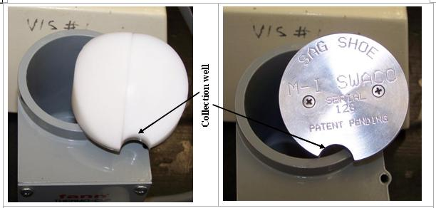
Figure A1: Sag Shoe (Provided by MI Swaco)
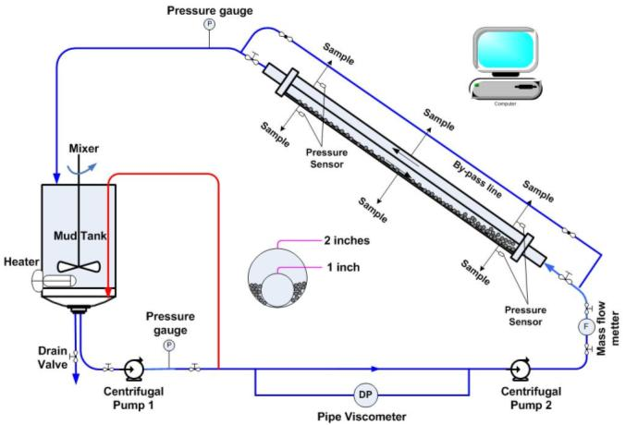
Figure A2: Schematic of the Small Scale Flow Loop
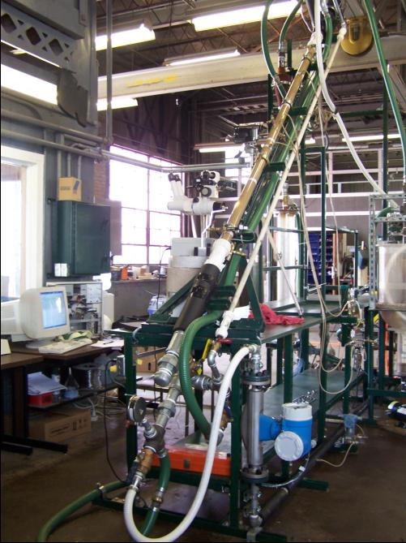
Figure A3: Small Scale Flow Loop (SSFL)

