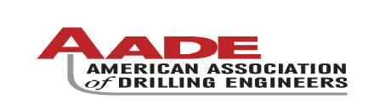
2009 National Technical Conference & Exhibition, New Orleans, Louisiana

AADE 2009NTCE-04-02: Recovering Existing Slots and Drilling Challenges in GOM TLP
Author(s) & Affiliations:
Oscar Quintero, Shell Oil Company & AADE
Abstract
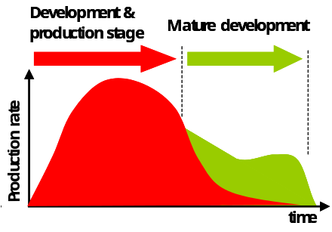
Mature Brownfield drilling at Shell's Auger Tension Leg Platform (TLP) in the Gulf of Mexico requires to deliver the well at a top performance to optimize Economic Field Life via (1) Maximize Production (2) Accelerate hydrocarbon extraction and maximize recovery as part of a Sustainable Development approach. These re-development wells are sidetracked from existing wells that are at their economic value limit. One of the main challenges of the Mature TLP development process is the selection of the adequate well slot. The existing well slot completion is pulled, deep-water tieback and cemented casing string is cut and pull to initiate the sidetrack stage. This presentation will cover the learnings around Mature Field development to optimize field life, specifics about slot selection criteria, drilling challenges around TLP and best practices for Slot Recovery fishing, Hole Cleaning and Liner Reaming in Extended Reach Drilling and Ultra Deep Drilling environments. These techniques and performance enabler’s practices are key drivers to unlock the potential of more opportunities mature in Mature TLP drilling re-development..
The Case “World Global Oil Consumption”
The global economic contraction continues to depress energy demand. The annual price of West Texas Intermediate (WTI) crude oil averaged $100 per barrel in 2008. The global economic slowdown is projected to cut these prices by more than half, to average $42 per barrel in 2009 and $53 in 2010 ¹
The World Global Oil Consumption has increased by 23mb/ d in the last 23 years. Current Oil consumption in 2009 has dropped 2mb/d to 83 mb/d. It is estimated that by the year 2030 Oil Consumption will be as high as 110 mb/d, eventhough the short-term economical outlook shows a reduction of oil demand, which for sure will rebound in the long term with development around the world. These statistics lead us to maximize the existing assets, in order to achieve positive Cash Flow and Maximize Oil recovery (as part of a Sustainable Development approach).
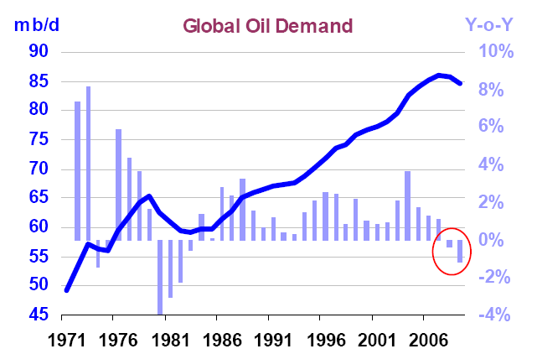

Mature TLP “Auger Re-Development History”
Auger TLP Overview
This TLP was installed in a water depth of 2,860 feet, a record for a permanent drilling and production platform in the Gulf of Mexico and first production was achieved on April 15, 1994.

The TLP was the first in the Gulf of Mexico to support both a drilling rig and complete production facilities. The rig is designed for drilling, completion and workover operations and is rated for 25,000 feet. There are 32 well slots.
Re-Development Plan
Auger Re-Development Plan integrates Production, Sub-Surface Development and Regulatory approach to (1) Maximize Production (2) Increase Positive cash Flow (3) Maximize Hydrocarbon Recovery. The key of Success of the Re-development is the Optimization of Field Life. Field life Optimization refers to the extension of the economic filed life by increasing production and Positive Cash Flow. Optimum Field Life is sometimes confused with a long tail production profile, however if the long tail production profile is below economic limit, then it is not a Optimum Field life approach. In the optimum case a sharp production decline is expected at a non-economic limit.. Economic Limit is calculated by the ratio between Operating Expenditure (OPEX) and Revenue.
This graph illustrates the impact of mature development in the extension of optimum field life (in green) via production increase and sharp end decline.

Re-Development success via (a) Process, (b) Technology, Techniques / Practices
(a) Process “Selection of the well to recover”
At Auger, there is no more opportunities for drilling a new well in this TLP but the only option is to re-use existing slots. One of they key factor of success has been the selection of Well Slot that will be used during redevelopment opportunity. In order to Select the Well Slot, Define and Execute the Sub-Surface opportunity, an Integrated process has been implemented. This process divided as follow: Screening, Enablers Identification, and Constraints.
Screening:
- Economic Limit, is evaluated per slot (OPEX per Slot/ Well Revenue)
- Well/ Slot Availability, an updated wellbore utilization table is available showing: Integrated Activities plan e.g. Acid Stimulations and Recompletions showing expected well life years and slot availability date for future sidetracks and other activities.
- Mechanical Feasibility, Identify and Assesses the chances of success of recovering slots via fishing of tieback and drilling casings.
- Sub-Surface Opportunities, usually identified in a Field development plan with opportunity ranking.
Enablers Identification:
- Integrated Asset Planning, Timeline with activities regarding Well maintenance, Drilling & completions, which drive Drilling & Well maintenance operations sequence.
- Rig Upgrade, drilling beyond original TLP limits e.g. Depth > 25,000 ft and Surface Pressures > 5,000 psi.
- Technology, Techniques & practices, are driving performance by reducing Trouble Time and improving previous performance (cost reduction).
Constraints:
- Top Side, because of Auger successful re-development campaign, then TLP is at its production limit capacity and this is consider when well slot prioritization and activities are ranked and evaluated.
- TLP Weight and People On-Board (POB) limitations, Auger can drill Big Hole Sidetracks only during winter. Note: Big Hole Sidetrack are usually done after pulling production tieback. This sidetrack requires the use of 21” risers and SSBOP stack, so due to storm draft required (weight limitation), in the vent of a hurricane in GOM, then Big-Hole Sidetracks are drilled only from November 15th to Jan 1st of each year. POB is usually limited due to the amount of production, construction, drilling, completion, well services, maintenance and interventions activities and people required.
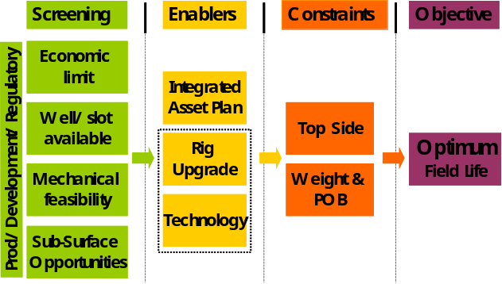
(b) Technology, Techniques / Practices
The existing well slot completion is pulled; deep-water tieback and cemented casing string are cut and pull to initiate the big hole sidetrack stage. The key learnings around Technology, Techniques-Practices are documented via After Actions Reviews. Non-Productive time has reduced from 30% average to 10% and construction cost by 30%. The key Technology, Techniques / Practices to be evaluated in this document are (1) Slot Recovery Best Practices (2) Extended Reach Drilling Practices:
- Slot Recovery Best Practices
  - Annular clearance and fluid evaluation; the presence of cement in cemented annulus that required to be pulled and amount of solids settles in annulus can lead to a low chance to cut & pull casing strings required to recover well slot.
  - Use strongest DP; as in regular fishing operations the maximum Overpull available will increase the ability to retrieve stuck casing hangers and apply required tension to move stuck casing strings (due to solids or cement)
  - Economic Analysis (fishing expenditure); evaluation of estimated cost and time for fishing operations in order to archive minimum cutting depth require to kick off the well and obtain desired casing design scheme.
  - Contingency planning,; pilot milling plan will be always a possibility in the event that casing is stuck and available overpull is not enough to get casing out of the hole.
- Extended Reach Drilling Practices
  - Hole Cleaning; Torque and Drag Modeling, Calibration while Drlg, Training-on-site (Believers) and monitoring are the key for success of hole cleaning in Extended Reached holes. See below picture of shakers at labeled depending on the volume of cuttings over shakers. At the moment of reporting the cuttings return over shaker, rig team identifies volume of cuttings based on this picture.
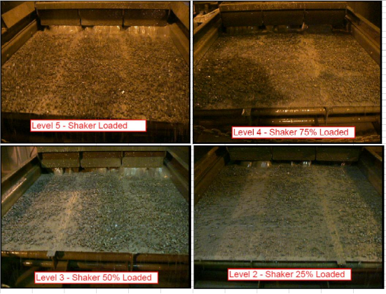
  - Liner Reaming; Case for Action: During the last 2 years, six (6) drilling / production liners have gotten stuck on TLP wells in GOM. The increase in well complexity (directional profile, sand depletion, shale instability has increased the probability of stuck casing 30% - 70% on recent wells from Brutus, Ursa, Auger and Mars TLPs. The resulting consequences are: (1) downsizing production liner which increases completion risk (2) re-drill to re-run liner (3) run SET to gain Fracture Gradient and continue drilling (4) exceeding AFE in time and cost. Total estimated cost to these six (6) trouble events could be as high as > 30% total well cost.
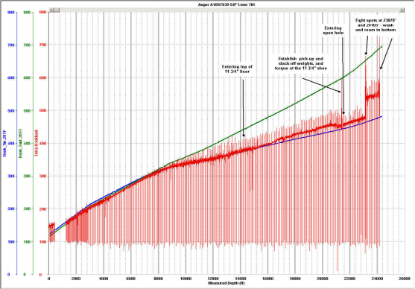
Conclusions and Re-development results
Auger 2006 – 2009 Re-Development performance has unlocked the potential of the 1st TLP ever installed in GOM. A new Drilling Sequence is in place with drilling sub-surface opportunities that were on-hold for more than 10 years extending Optimum Field Life and providing positive Cash Flow to Shell Oil Company in the Mature TLP business. During Auger Re-Development 2006-2009, new production account for ~ 70% of all TLP production in 2008 and investment achieve positive cash flow in less than one-year.

References
1. Energy Information Administration (EIA). “Short Term Energy Outlook”. March 10th, 2009 release.

