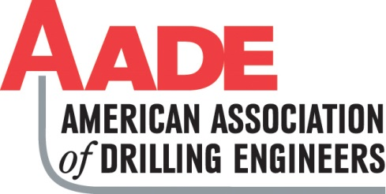

Date

I appreciate the opportunity to serve as the AADE University Name Student Section faculty advisor. The student section has my full support in providing an outlet for student members to network with professionals in the Oil & Gas Industry and introducing new technology to students. I understand the Qualifications and accept the Responsibilities of being selected as the AADE University Name Student Section Faculty Advisor as listed below and stated in the ByLaws.

Qualifications
• The section advisor must be a full-time member of the University faculty or staff.

Responsibilities
• Serves as the official liaison between the student section and the University, and
the student section and AADE chapter liaison.
• Advises the student section on formation and implementation of its goals,
objectives, and programs.
• Attends as many of the student section meetings as possible and is available to
student section members as much as possible.
• Ensures that the student section understands the role of the AADE as a
technical/professional organization.
• Attends AADE chapter meetings when possible.

I agree to support the University Name Student Section of the AADE.

________________________________
Advisor Name
Position
Contact info

